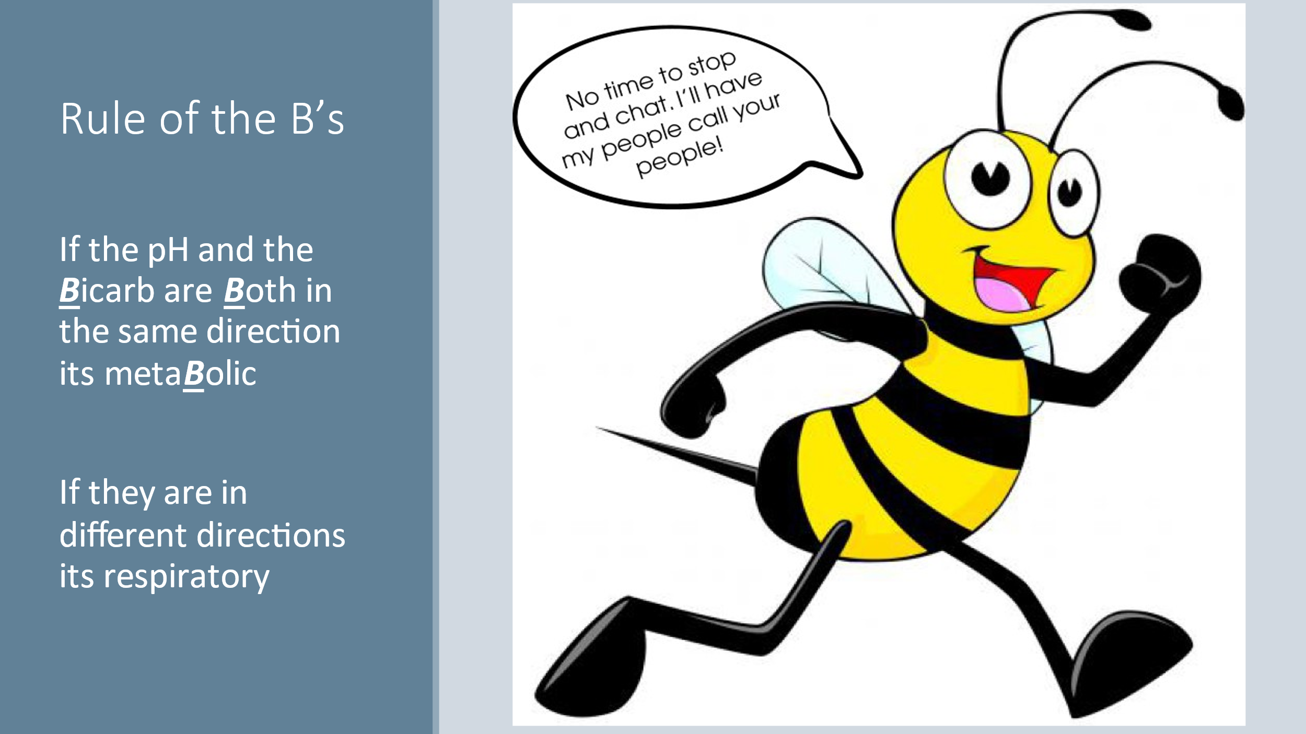

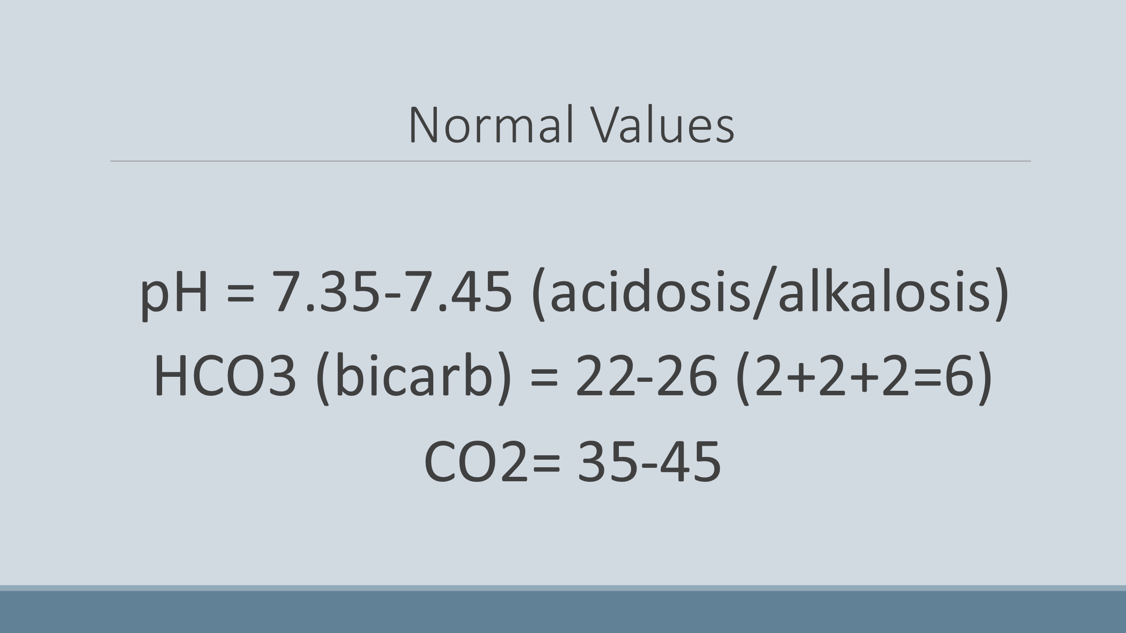

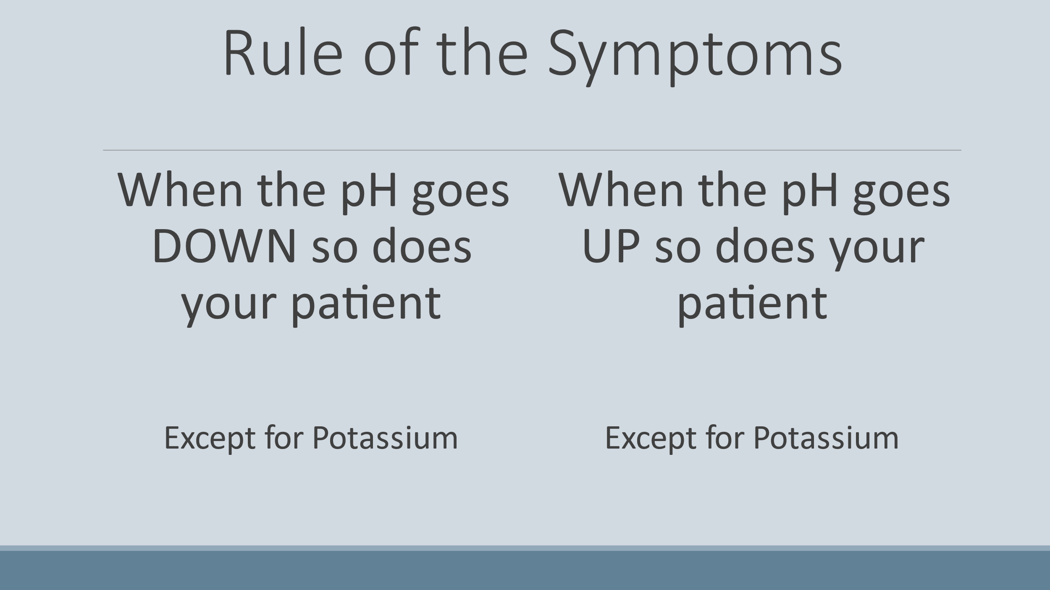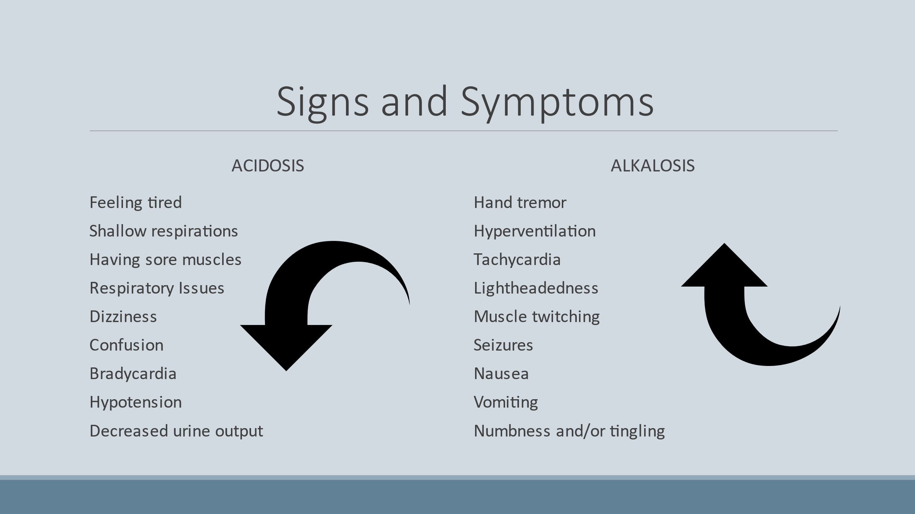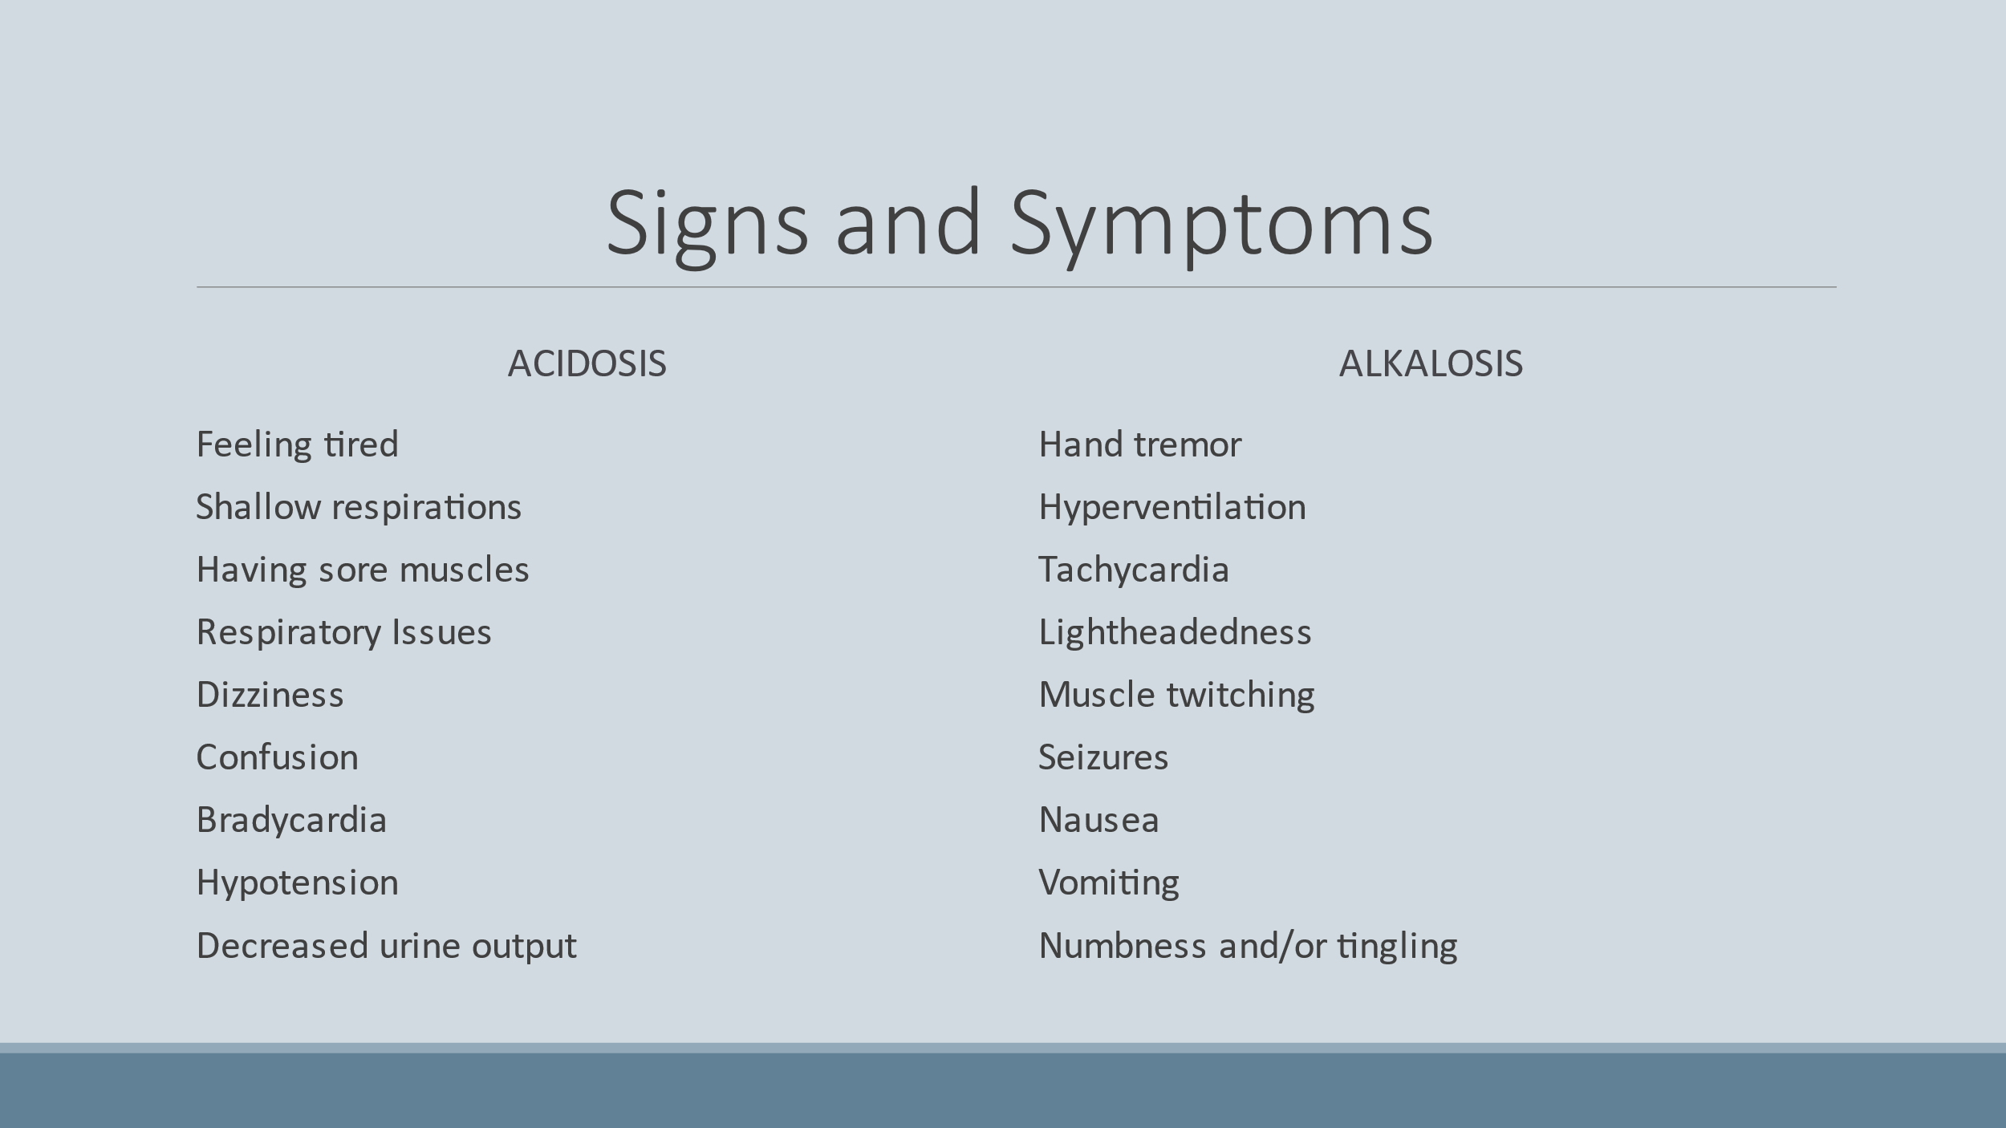

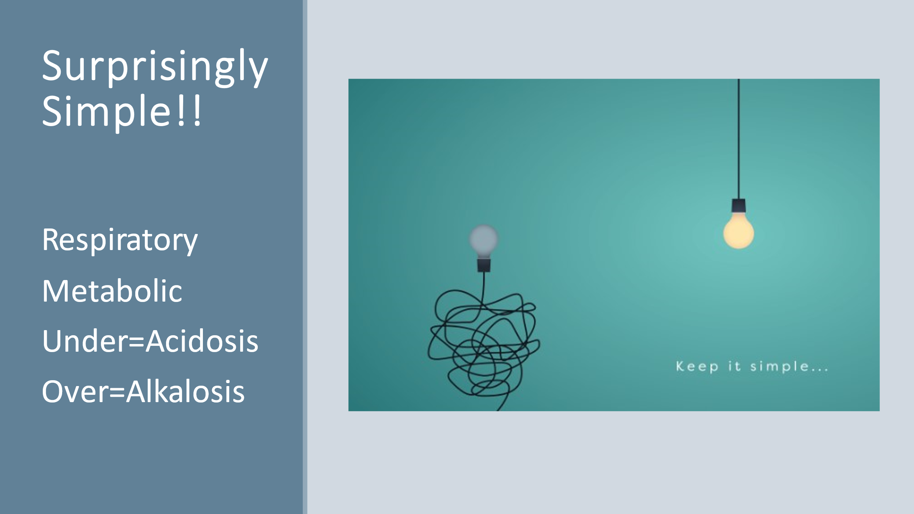

There are 3 buffer systems within the body that help to regulate acid/base balance

* Carbonic Acid System/ Bicarbonate (Ratio is 1:20) see diagram 18.6 on page 496
* Respiratory system (more rapid correction of abnormalities)
* Renal system (slower correction of abnormalities)

FLUID COMPARTMENTS:

Fluid (water or H2O) is either inside the cell or outside the cell and in the vessels or outside of the vessels.

* 50-60% of an ADULT body is made up of H2O
* As we age this percentage decreases, the thirst mechanism is altered therefore patients can have inadequate water intake
* Plasma is the liquid portion of the blood which carries around cells and other components
* A loss of 20% of body fluid can be DEADLY!!
* REMEMBER that the recommended intake of water is 2500 per day
* Urine Output must be 30ml per hour or greater…anything less and the patient is dehydrated OR the KIDNEYS are not functioning as they should
* We weigh patients at the same time of day because it gives us an accurate determination of water balance.
* We lose fluid in a variety of ways
* Respiration (LUNGS) 350 ml/day
* Integumentary (Skin Sweating) 500 ml/day
* GI Tract (Feces) 150 ml/day
* Kidneys (urination) 1500 ml/day
* GRAND TOTAL 2500 ml/day

|  |  |  |  |
| --- | --- | --- | --- |
| **MOVEMENT OF FLUIDS AND ELECTROLYTES** | | | |
| DOES NOT REQUIE ENERGY (PASSIVE TRANSPORT) | | REQUIRES ENERGY (ACTIVE TRANSPORT) | |
| **Osmosis**: movement of fluid (water) remember the **“O”** in **O**smosis connects to H2**O** | | The movement of **ELECTROLYTES** in and out of cells. This requires channels on the membrane of the cell…think of these as doors with locks that only certain electrolytes have the keys to. | |
| **Diffusion:** the movement of “stuff” or particles (these particles can be electrolytes) | | These keys are electrical charges known as IONS…they can be positively (+) charged (cations) or negatively (-) charged (anions. | |
| **Filtration:** movement by **hydrostatic pressure**. Think of a fine mesh colander that you are trying to drain the water out of some food. If you press down on the food the water drains out faster. | | **Cations:**   * Sodium (Na+) The MOST abundant in the extracellular compartment * Potassium (K+) * Magnesium (Mg+) * Calcium (Ca+)   **Anions:**   * Chloride (Cl-) * Bicarbonate (HCO3-) * Sulfate (SO4-) * Hydrogen Phosphate (HPO4-) | |
|  | |  | |
| **ELECTROLYTES** | | | |
| **SODIUM**  135-145  Remember: Sodium and water go together…the body tries to dilute high sodium levels by retaining water and vice versa  Found in Cheese, Processed Foods, Seafood, & Table Salt | Regulates muscle contractions especially in the heart. | **HYPONATREMIA <135**  Usually occurs from excessive intake of water or vomiting and diarrhea.  Sx: muscle issues like cramping/weakness, confusion, edema, seizures  Tx: Na+ replacement through concentrated Na+ solution | **HYPERNATREMIA >145**  Caused by excessive Na+ intake or decreased water intake.  Sx: Patient will be DRY, decreased urinary output, restlessness, agitation, confusion.  Tx: decrease sodium intake and replace fluid volume with no sodium added IV fluids (dextrose in water for example) |
| **POTASSIUM**  3.5-5  Found in Leafy Greens, Apricots, Asparagus &  Bananas | Promotes the transmission of nerve impulses (heart) and regulates water concentration intracellularly | **HYPOKALEMIA <3.5**  Usually caused by kidney (renal) disease or prolonged vomiting/diarrhea/gastric suctioning, Potassium WASTING diuretics (furosemide)  Sx: Affects skeletal and cardiac muscle function, Cardiac arrythmias, EKG changes, hyporeflexia (decreased deep tendon reflexes), ***POLY***uria  Tx: IV or Oral K+ replacement | **HYPERKALEMIA >5**  Usually caused by Kidney Failure, Potassium SPARING diuretics (spironolactone). Over intake of potassium supplements  Sx: Similar to HYPOkalemia, abnormal EKG & dysrhythmias, Cardiac arrest but they will have ***AN***uria  Tx: Kayexelate (most common) orally or rectally. Also can be given HIGH dextrose solution followed by insulin to pull the K+ back into the cells |
| **CALCIUM**  4.5-5.6.  If the levels in the blood are too low the Ca+ will be pulled out of the bones to regulate the blood levels. This can cause weak bones and teeth (osteoporosis)  Found in dairy products, nuts and egg yolks | Promotes the formation of strong bones and teeth | **HYPOCALCEMIA <4.5**  Caused by Renal Failure, Vitamin D or parathyroid deficiency, vomiting/diarrhea/excessive gastric suctioning  Sx: Hyperactive deep tendon reflexes, TETANY (+Trousseau and Chvostek signs). **REMEMBER** the difference…***C***hvostek starts with ***“C”*** and so does “***C***heek”  Tx: IV Calcium Gluconate or Oral Supplements | **HYPERCALCEMIA >5.6**  Caused by excessive intake of Ca+ (supplements, certain antacids, increased Vitamin D and Parathyroid hormone levels), Bone Cancers  Sx: Renal Calculi (Kidney Stones), thirst and polyuria, bone pain, cardiac dysrhythmias and cardiac arrest  Tx: increase fluid intake to 3000-4000 ml/day while also administering diuretics. |
| **PHOSPHOROUS**  2.4-4.1  It has an INVERSE relationship with Ca+, one goes up the other goes down and vice versa, very important to have sufficient intake while pregnant and breast feeding  Found in Meat, Dairy, and Legumes | Supports bones and teeth with Ca+, important component of DNA & RNA, assists in muscle and nerve activity | **HYPOPHOSPHATEMIA <2.4**  Dietary insufficiency, kidney disease (hypophosphatemia is RARE).  Sx: Muscle weakness (think RESPIRATORY muscles), bone and joint pain  Tx: Oral or IV supplementation | **HYPERPHOSPHATEMIA > 4.1**  Increased dietary intake, kidney disease (also RARE)  Sx: Tetany, numbness and tingling around the mouth, muscle spasms.  Tx: Administer phosphate binding medication (aluminum hydroxide) and IV Ca+ (remember if Ca+ levels increase phosphorous will decrease!) |

Intravenous Therapy:

* Symptoms of dehydration include hyperthermia, skin tenting, dizziness, hypotension, tachycardia.
* Symptoms of fluid overload include rapid weight gain, edema, ascites (fluid buildup in abdomen) hypertension, shortness of breath, congestive heart failure.
* NS (Normal Saline) is the same concentration of blood
* Different IV tubings have different Drip Rates (GTT Rates). This means how many drops equal 1 ml. Tubing comes in 10GTT/ml, 15 GTT/ml, and 60 GTT/ml.

Blood Transfusions:

* In FLORIDA initiating a blood transfusion is NOT within the scope of practice for the LPN/LVN
* The LVN can monitor the vital signs and report s/s of transfusion reaction.
* The patient has to have a blood Type and Crossmatch recently (usually within 72 hours) and they will wear a special band with stickers on it
* Blood must be checked by TWO RNs prior to initiating the transfusion. The check must include:
* Blood type and Rh factor (positive or negative)
* Expiration
* Blood Bank ID must match the band of the patient
* Expiration Date
* Time (must be infused within 30 minutes of getting from Blood Bank and completed in 2-4 hours)
* And more
* S/S Transfusion Reaction include:
* Chills
* Fever
* Low back pain
* Pruritus (itching)
* Urticaria (hives)
* Chest pain
* Wheezing
* Dyspnea
* If any signs of reaction (usually starts within the first 15 minutes but can happen at ANY time during the transfusion…REMAIN with the patient for the first 15-20 minutes) STOP the transfusion and let NS run in (Clamp the blood tubing and open the NS tubing)
* **Auto**logous infusions are from the patients OWN blood which they would have previously donated…therefore little to NO risk of a reaction (unless a mistake was made, and the wrong blood was given)

|  |  |  |  |
| --- | --- | --- | --- |
| Peripherally Inserted IV | Central Venous Access Devices (CVADS) | Peripherally Inserted Central Catheter (PICC) | Implanted Infusion Ports |
| Used for a short duration…maximum is a few days.  The Gauge of catheter is determined by the nurse depending on the veins and what will be infused.  The larger the number the smaller the catheter.  20,21,22 Gauge is fine for routine IV fluid administration.  For Blood administration or other thicker solutions, a 16, 18, 20 is recommended.  24 gauge is reserved for very thin fragile veins and pediatric patients. | Used for a longer duration…weeks to months.  Prevents repeated needlesticks.  Inserted by the physician and go directly into the superior vena cava just above the right atrium.  Usual entrance is the chest or jugular vein in the neck.  Can have multiple lumens to run different therapies at the same time.  Can be used for thicker infusions (blood, TPN) or caustic infusions (chemotherapy) that cannot be given through a peripheral line. | Used for longer periods 7 days to 3 months.  Prevents repeated needlesticks.  Entrance in in the arm and the catheter is threaded up the vessel to the superior vena cava just above the right atrium.  Can have multiple lumens to run different therapies at the same time.  Can also be used for thicker and caustic infusions. | Used for the longest duration (can be maintained and used for the patient’s life) typically for those with chronic illnesses and cancers who need repeated and frequent infusions.  The port is then sutured to the chest wall and covered by the skin.  It then threads to the superior vena cava just above the right atrium.  Accessed by a huber needle which is a needle with a 90 degree angle. |
| Can be inserted by the nurse at the bedside  Peripherally Inserted IV | Can be inserted by the physician at the bedside with local anesthesia.  Central Venous Access Devices (CVADS) | Can be inserted by trained RN or Interventional Radiologist.  Peripherally Inserted Central Catheter (PICC) | Inserted in the operating room under local or general  Implanted Infusion Ports |
| Risks include:   * Infiltration which is seepage of fluid from the vessel into the surrounding tissue * Phlebitis: Inflammation of the vein from irritation either mechanical, chemical or bacterial. * Septicemia: bacteria enter the bloodstream causing widespread infection | Risks include:   * Infection can be prevented by routing sterile dressing changes weekly or when the dressing is soiled, wet, or contaminated in any way. * Clogging (occlusion)is prevented by flushing every shift with NS followed by a heparin solution. * Pneumothorax, hemothorax, and air embolism in the pleural space is accidentally entered. | Risks Include:   * DVT (deep vein thrombosis) usually in the arm. This is where a clot forms around the catheter and occludes blood flow. * Infection can be prevented by routing sterile dressing changes weekly or when the dressing is soiled, wet, or contaminated in any way. * Clogging (occlusion)is prevented by flushing every shift with NS followed by a heparin solution. * Little risk of pneumothorax,hemothorax or air embolism. | Risks Include:   * Infection can be prevented by routing sterile dressing changes weekly WHILE IT IS ACCESSED or when the dressing is soiled, wet, contaminated in any way. * Clogging prevented by flushing monthly when NOT in use or every shift when ACCESSED AND IN USE with NS followed by a heparin solution. |

