|  |  |  |  |  |
| --- | --- | --- | --- | --- |
| Component | Range | High | Low | Key Considerations |
| RBCs (Erythrocytes)  Total number of RBCs |  | Dehydration  Polycythemia (too many RBCs treated with repeated phlebotomies and busulfan (Myleran) to inhibit bone marrow activity | Anemia  Leukemia  Hemorrhage | Produced in the Red Bone Marrow  The main cellular component of blood  Peripheral Smear examines the shape and structure of RBC |
| Hemoglobin  Total amount of Hgb | Males 14-18  Females 12-16 | Dehydration  Polycythemia  COPD | Anemia  Hemorrhage  (may see dyspnea) |  |
| Hematocrit  Percentage of blood volume that is made up by RBCs | 3x the Hgb | Dehydration  Polycythemia  Severe burns | Anemia  Leukemia  Hemorrhage |  |
| White Blood Cells  (Leukocytes) | 5-10k | Bacterial Infection  Trauma  Leukemia | Chemotherapy  Radiation  Aplastic Anemia  Agranulocytosis  Autoimmune Disease  (puts us at risk for infection) |  |
| Platelets  (Thrombocytes) | 150-400k | Leukemia  (Will see clotting) | Aplastic anemia  Thrombocytopenia  (Will see bleeding) |  |
| Plasma | 45-55% of blood (we don’t measure it in CBC) | Dehydration | Fluid overload | Carries all the cells around |
| Differential | Reliable indicator of the body’s level of infection or level of recovery | Neutrophils  Eosinophils  Basophils  Lymphocytes (B&T cells)  Monocytes | Shift to the Left means that there is a shift in the [WBC](https://www.bing.com/ck/a?!&&p=98c52307b32ad065JmltdHM9MTY4MjAzNTIwMCZpZ3VpZD0zMTcyODc1Ny0yNmE2LTYyYzAtMzkyMS05NjE1MjcwMTYzMDYmaW5zaWQ9NTQzNw&ptn=3&hsh=3&fclid=31728757-26a6-62c0-3921-961527016306&u=a1L3NlYXJjaD9xPVdoaXRlK2Jsb29kK2NlbGwmZmlsdGVycz1zaWQlM2EwZTc4NDBjOS1lNmU4LTBlMDktYjJmMC1jZWYxYTE1MmNlMGEmZm9ybT1FTlRMTks&ntb=1) towards more immature cells (more bands and blasts). This is observed in most bacterial infections and in some cancers. | Shift to the Right means that there has been a**shift back to the normal Diff**. |

Fun Facts about Blood:

* 500ml is stored in the spleen in case of hypovolemic emergency
* Spleen also destroys worn out blood cells and promotes phagocytosis
* Jehovah’s Witnesses will accept Autologous blood transfusions

* Life span of an erythrocyte (RBC) is 120 days
* Life span of a sickled RBC is only 10-20 days
* Life span of Leukocyte is a few days to a few years
* Life span of Thrombocyte is 5-9 days
* Neutrophils destroy by releasing ***lysozyme*** and remove cellular waste, bacteria and solid particles by phagocytosis
* Neutrophils play the biggest role in allergic reactions and will be elevated with severe burns
* But Basophils release HISTAMINE which is a strong vasodilator if allergens are present
* AND Eosinophils will also increase to 10%
* Immature neutrophils are present if there is overwhelming bacterial infection (cant produce new ones fast enough)
* Lymphedema: restrict intake of protein

|  |  |
| --- | --- |
| How Red Blood Cells are Made (Erythropoiesis)  The necessary factors that support healthy erythropoiesis are amino acids, healthy bone marrow, healthy kidneys, vitamin B2 & Vitamin B12 | 1. Oxygen delivery is decreased to the tissues 2. This stimulates the kidneys to release erythropoietic factor 3. This stimulates the red bone marrow 4. There is an increase in Red Blood Cell production 5. Oxygen delivery increases to the tissues 6. Red Blood Cell production decreases |

|  |  |  |  |  |  |  |
| --- | --- | --- | --- | --- | --- | --- |
| Anemia | Etiology | Manifestations | Assessment | Testing | Management | Teaching & Interventions |
| Hypovolemic | Acute or Chronic blood loss | Restlessness  ⭡RR  ⭡ thready HR  Hypotension, Weakness  Pale, cool, clammy skin, pallor | S: thirst, weakness, irritability, restlessness  O: Cold, clammy, skin with pallor, Oliguria | CBC  Early ⭡RBCs  Late ⭣RBCs | IV Hydration  Transfusion hgb <8 symptomatic or <7 asymptomatic | Monitor urine output & Vitals  Monitor bleeding  Alternate rest with activity to reduce fatigue |
| Pernicious | Vitamin B12 deficiency (usually due to reduced or absent intrinsic factor) | Same as anemia  Smooth, thick RED tongue | S: digestive issues, flatulence, constipation, diarrhea  O: confusion, memory loss | CBC  Endoscopy  Reticulocyte count (immature RBCs)  Normal Schilling test would show 20% excretion of radioactive vitamin B12 | B12 replacement  1000mcg daily for 2 weeks IM, weekly until level is normal, then monthly for maintenance | This is a lifelong disease that will require lifelong treatment.  Provide a lightweight blanket |
| Aplastic | Bone marrow does not produce enough RBCs | Same as anemia  Patient will be ***PANCYTOPENIC*** | S: same as anemia, cold hands and feet, headaches, chest pain  O: epistaxis, frequent infections, petechiae, blood in stool, coke colored urine, heavy menstrual bleeding | CBC  Reticulocyte count  Bone marrow aspiration (taken from the posterior iliac crest) | Treat the cause  Splenectomy  Corticosteroids  Immunotherapy  Bone marrow transplant  Stem Cell Transplant | Teach to protect self from bleeding/injury  Avoid infection  Prior to bone marrow transplant total body irradiation must be done to kill all the marrow cells |
| Iron Deficiency | RBCs contain less Hgb than normal  Caused by malabsorption, low iron intake, diverticulosis, ulcers, hiatal hernia, Tumors (all cause chronic blood loss) | Same as anemia  Smooth thick red tongue | S: pagophagia (desire to eat ice), GI symptoms, glossitis (tongue soreness) | CBC with ⭣RBCs, ⭣Hgb, ⭣Hct  ⭣Serum iron levels | ***Ferrous Sulfate*** take with Vitamin C for best absorption  If IM use Z-track to prevent skin staining  Iron infusions with Venofer (iron sucrose) | Increase iron in diet, dark meat chicken, beef, whole grain breads, nuts and dried fruit  If dose of ferrous sulfate is missed don’t double up next dose  If liquid ferrous sulfate drink through straw |
| Sickle Cell | Abnormal crescent shaped RBCs  Must have genes from both parents (homozygous) to have disease  Carriers have 2 different genes (heterozygous) | Sickle cell crisis: misshapen RBCs clump in the small blood vessels. Tissue hypoxia and ischemia occur | S: severe pain especially in the joints of the hands and feet, abdominal pain (spleen and organ engorgement), priapism  O: Jaundice, edema of the extremities | Electrophoresis  Xrays  MRI | NSAIDS for pain  Opioids if severe  Oxygen  IVF for hydration  Immunizations to prevent infection | Avoid alcohol, smoking, cold, overexertion, infection, physical and emotional stress |

|  |  |  |  |
| --- | --- | --- | --- |
| Type | Manifestations | Testing and treatment | Care and Teaching |
| Hemophilia A is most common (Factor VIII)  Hemophilia B is rare (Factor IX) | Severe bleeding from minor injuries  Bleeding into the joint spaces (hemarthrosis)  Deep bruising (ecchymoses) | Factors VIII or IX deficient or absent dependent on type  Treat with transfusions of blood and plasma and administration of Recombinant Factor VIII or IX dependent on type | Splint the joints where hemarthrosis exist to maintain alignment end reduce pain  Affects mostly males and females are carriers |

|  |  |  |  |  |  |  |
| --- | --- | --- | --- | --- | --- | --- |
| Cancer | Etiology | Manifestations | Assessment | Tests | Treatment | Teaching and Interventions |
| Leukemia | Excessive numbers of abnormal leukocytes accumulate in the bone marrow and lymph nodes | Sometimes diagnosed when there is fever of unknown origin, otherwise the symptoms dictate further testing | S: pain in the bones and joints, irritability, malaise, fatigue  O: CBC measurements, + cultures of throat, urine, stool, etc., petechiae, ecchymoses, bleeding gums | CBC (anemia and thrombocytopenia)  Bone Marrow Biopsy  CT scans  MRIs | Bone Marrow Transplant (best matches are from siblings or autologous)  Chemotherapy | ALL-Affects lymphoid cells, most common in children  AML-Affects Myeloid cells  CLL-Affects B cells  CML-Affects myeloid cells  Make sure vaccinations are up to date!! Including flu vaccines every year.  Prevent Infection! |
| ***Hodgkin Disease*** | Painless enlargement of lymphoid tissue (lymph glands)  Exact cause is unknown | Painless enlarged lymph nodes | S: fatigue, loss of appetite. Night sweats, pruritus, some have pain behind the sternum  O: Fever, palpable lymph nodes, splenomegaly, hepatomegaly, abdominal tenderness | Reed-Sternberg cell detection  Chest xray/CT scan/MRI  PET scan (to look at lymph nodes and how they might be responding or NOT responding to therapy) | Chemotherapy and radiation therapy | Comfort therapy, treat the pruritus with cool baths and lotions, manage pain |
| Multiple Myeloma | Excessive numbers of abnormal plasma cells accumulate in the bone marrow and produce tumors that destroy bone | Back pain, frequent bacterial infections | S: Back, ribs, pelvis and spinal pain  O:fever, bleeding, objective s/s pain, hypercalcemia | Monoclonal Protein (‘M Protein”) | Chemotherapy  Radiation | Closely supervise when ambulating (fall risk with fragile bones so risk for pathologic fractures)  Teach to avoid traumatic bone injury and infection) |

-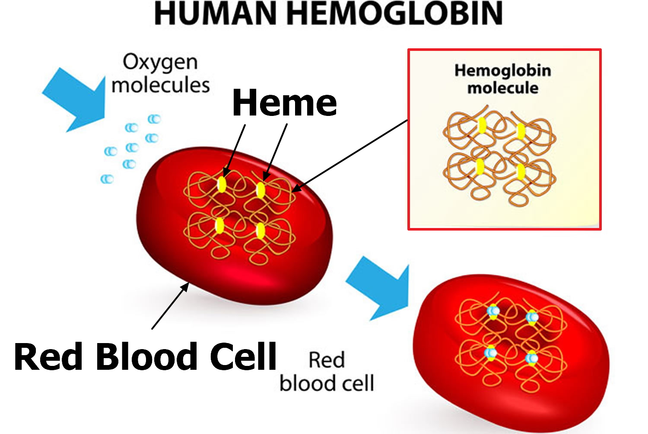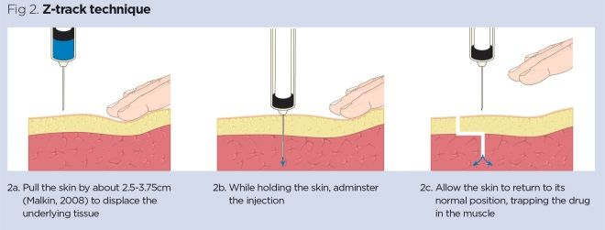

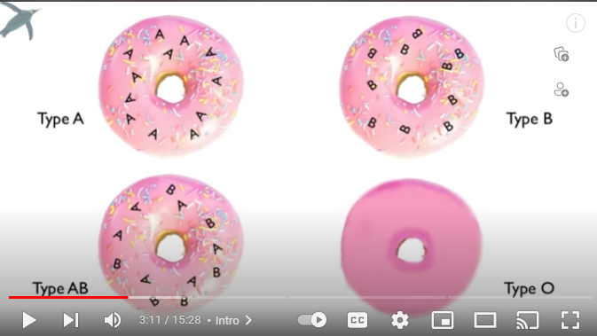

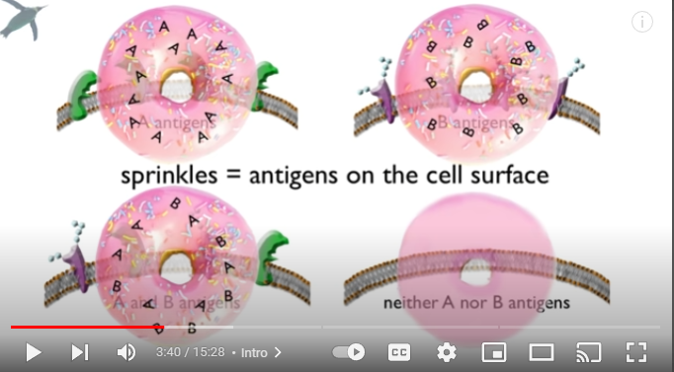

**Type AB Universal Recipient Type O Universal Donor**