Visual Acuity (sharpness) is measured 20/???

So, someone whose vision is 20/80 means the patient can see the ***SNELLEN CHART*** as clearly at 20 feet as someone with ‘normal’ vision would see at 80 feet.

Most inner part of the eye is the ***CHOROID***

***CONVERGENCE*** is the medial movement of both eyes, allowing light rays from the object to hit the same point on both retinas or the ability to turn the two eyes inward toward each other to look at a close object.

***DIVERGENCE*** is the lateral movement of both eyes and is the ability to turn the two eyes outwards to look at a distant object.

***ACCOMODATION*** is when the lens changes its curvature to focus on the retina.

***CHEMICAL SPLASH*** in eyes flush for 20 minutes with normal saline.

***PENETRATING WOUND*** lie the patient FLAT.

**CONES** are to see color (in bright light) **RODS** are to see light (twilight light)

|  |  |  |  |
| --- | --- | --- | --- |
| CONDITION | SYMPTOMS | TREATMENT | VISUAL |
| Myopia  “Nearsighted” | Can’t see distant objects clearly… There is an elongation of the eyeball, causing light rays to focus in front of the retina. | Radial Keratotomy (RK)  Photorefractive Keratotomy (PRK)  Laser Assisted in situ Keratomileusis (LASIK) most common works by removing some internal layers of cornea. |  |
| Hyperopia  “Farsightedness” | Can’t see close objects clearly (usually from birth) | Corrective Lenses |  |
| Presbyopia  “Farsightedness” | AGE related loss of acuity regarding close object (need reading glasses) | Corrective Lenses |  |
| Astigmatism | Difficulty seeing both close AND distant objects because the eye is not perfectly round | Corrective lenses, RK, PK or LASIK |  |

In ANY patient with vision loss the most important thing for the nurse to do is determine how this patient’s visual impairment affects normal functioning.

Get patients in contact with the American Foundation for the Blind where they will provide them with a list of local agencies that can assist them.

If you are assisting a blind person in unfamiliar surroundings encourage them to ask for verbal cues, describe the surroundings to them, place their hand on your shoulder or elbow.

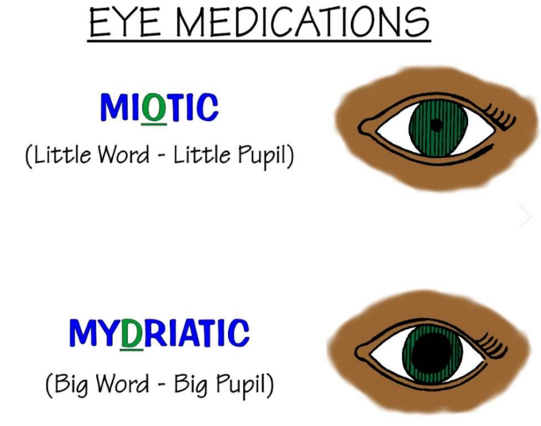

|  |  |  |  |
| --- | --- | --- | --- |
| DISORDER | PATHOPHYSIOLOGY | SYMPTOMS | TREATMENT |
| SJOGREN SYNDOME | Autoimmune- attacks the glands that produce tears (the lacrimal glands) and saliva (the salivary glands), impairing the glands' ability to secrete these fluids. | blurred vision, a feeling of grittiness, redness, and stringy mucus in the eyes. | None |
| CATARACTS | Clouding of the lens caused by UV light exposure, smoking, long-term corticosteroid use, exposure to rubella in utero, diabetes mellitus | Difficulty driving at night | Phacoemulsification which ‘breaks’ the cataract with ultrasound. NO heavy lifting after as it ⭡IOP |
| DIABETIC RETINOPATHY | Hemorrhages in the capillaries of the retina | Eye floaters  Blurriness  Black spots in the area of vision  Loss of central vision  Blindness | Vitrectomy (patient must remain face down for 4-5 days after the procedure)  Photocoagulation procedure destroys new blood vessels, seals leaky vessels, and helps prevent retinal edema |
| DETACHED RETINA | **Emergency situation in which a thin layer of tissue (the retina) at the back of the eye pulls away from its normal position.** | Flashing lights, vision looks like a curtain is closing over the eye | Pneumatic Retinopexy places a bubble of gas to put pressure on the damaged retina. |
| GLAUCOMA | **Open-angle glaucoma**   * No symptoms in early stages * Gradually, patchy blind spots in your side vision. Side vision also is known as peripheral vision * In later stages, difficulty seeing things in your central vision   **Acute angle-closure glaucoma**   * Severe headache * Severe eye pain * Nausea or vomiting * Blurred vision * Halos or colored rings around lights * Eye redness | Large, fixed pupil is common | Miotic drops constrict the pupil and open the Canal of Schlemm. Do ***NOT*** use mydriatic drops!!  Surgical ‘hole’ placed so that the fluid can circulate properly and not have increased pressure. |
| ENUCLEATION | Accidental or intentional removal of the eye |  | Apply pressure dressing on the socket |
| MACULAR DEGENERATION | causes blurred or reduced central vision due to the breaking down of the inner layers of the macula. The macula is the part of the retina that gives the eye clear vision in the direct line of sight. | Loss of central vision progressing to total blindness | Different types of laser surgeries depending on if it is “dry” or “wet” |

Ask patient if they see any distortion of the grid…that is ABNORMAL.

**AMSLER TEST**

|  |  |  |
| --- | --- | --- |
| TYPE | PATHO/SYMPTOMS | NOTES |
| Conductive | Some defect in getting sound through the ear. Can be caused by buildup of cerumen, foreign bodies, otosclerosis (ankylosing of the stapes), otitis media with effusion. | Corrected with tympanoplasty…post op ***ELEVATE*** the head with operative side facing upward.  Weber test will be ***louder*** in the ***affected*** ear. |
| Sensorineural | Defect in inner ear, trauma, infection congenital, ototoxic drugs, destruction of cochlear hairs from loud sound | Hearing aides may or may not help |
| Mixed | Combined conductive and sensorineural |  |
| Congenital | From birth or infancy from lack of oxygen, trauma, rH incompatibility or maternal infection |  |
| Functional | No organic cause can be from emotional or psychological factors |  |
| Central | Stemming from the brain (stroke or tumor) |  |

|  |  |  |  |
| --- | --- | --- | --- |
| DISEASE | PATHO/SYMPTOMS | TREATMENT | NOTES |
| External Otitis | Infection or inflammation of the external ear or canal (swimmers ear). The side of the head may hurt. There may be redness and swelling, and there is pain with chewing. | Topical antibiotics and steroid creams |  |
| Otitis Media | Infection of the middle ear usually staph or strep | Oral Antibiotics such as Ceclor (no alcohol intake) | Can be caused from exposure to cigarette smoke, allergies, upper respiratory infections.  More common 6/36 months as their eustachian tubes are shorter and straighter.  Myringotomy if severe by using a scalpel or heated wire to relieve pressure |
| Labyrinthitis  (Otitis Interna) | Infection or inflammation of the inner ear. Causes severe vertigo, nausea, and vomiting. | Antibiotics and Dramamine | When vertigo strikes have the patient lie flat until it passes. |
| Meniere’s Disease | Chronic increase in endolymph fluid in the inner ear causing tinnitus, vertigo, unilateral deafness from the increased pressure | Surgical destruction of labyrinth (will have no hearing), Subarachnoid shunt (drains fluid), Cryosurgery (should retain some hearing) Vestibular nerve dissection (preserves hearing in 90%) | Keep on sodium restricted diet. |
| Otosclerosis | Stiffening of the stapes making it so it cannot move or vibrate causing tinnitus then deafness. | Calcium, Vitamin D, & Fluoride  Stapedectomy | After stapedectomy, the patient facing the opposite side (surgical ear up), leave the bed ***FLAT***, medicate immediately if nauseous. ***NOTE*** hearing will ***NOT*** return until the ***EDEMA*** subsides!  After ANY ear surgery activity will be limited for at least a week. |

DON’T overaccentuate words when speaking with hearing impaired.

If a hearing aid is whistling, instruct the patient to reinsert the ear mold.

When teaching health promotion for visually and hearing impaired consider cultural beliefs, values, and habits.



