What Is Diabetes Mellitus?
Diabetes Mellitus (DM) is a chronic metabolic disorder characterized by high blood glucose levels (hyperglycemia) due to either:
- Insufficient insulin production (Type 1 DM).
- Insulin resistance (Type 2 DM).
- Other causes, such as gestational diabetes or genetic defects.

Types of Diabetes
1. Type 1 Diabetes (T1DM)
- Cause: Autoimmune destruction of insulin-producing beta cells in the pancreas.
- Onset: Often in childhood or adolescence.
- Key Feature: Requires lifelong insulin therapy.
- Symptoms: Polyuria, polydipsia, polyphagia, weight loss, fatigue.
2. Type 2 Diabetes (T2DM)
- Cause: Insulin resistance and beta cell dysfunction.
- Onset: Typically in adults, but increasing in children due to obesity.
- Key Features: May be managed with lifestyle changes, oral medications, or insulin.
- Risk Factors: Obesity, sedentary lifestyle, family history, hypertension, dyslipidemia.
3. Gestational Diabetes Mellitus (GDM)
- Cause: Hormonal changes during pregnancy causing insulin resistance.
- Onset: During pregnancy; resolves postpartum in most cases.
- Complications: Increases risk of Type 2 DM later in life.
4. Other Types
- Secondary Diabetes: Caused by medications (e.g., steroids) or medical conditions (e.g., pancreatitis).

Pathophysiology of Diabetes
- Normal Glucose Regulation:
  - Insulin is produced by the beta cells of the pancreas.
  - It facilitates glucose uptake into cells for energy.
- In Diabetes:
  - Insufficient insulin or insulin resistance leads to high blood glucose levels.
  - Prolonged hyperglycemia damages blood vessels and organs.
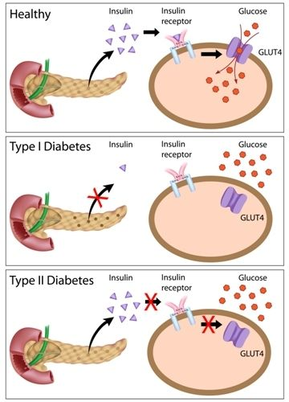

Signs and Symptoms
"3 Ps" of Diabetes
- Polyuria: Excessive urination due to glucose spilling into urine.
- Polydipsia: Excessive thirst due to dehydration.
- Polyphagia: Excessive hunger due to lack of glucose uptake by cells.
Other Symptoms:
- Fatigue, blurred vision, slow-healing wounds, recurrent infections, weight loss (T1DM).

Complications of Diabetes
1. Acute Complications
- Hypoglycemia:
  - Low blood sugar (<70 mg/dL).
  - Symptoms: Sweating, shaking, confusion, palpitations.
- Diabetic Ketoacidosis (DKA):
  - Common in T1DM.
  - Symptoms: Fruity breath, rapid breathing, nausea, abdominal pain, altered mental status.
- Hyperosmolar Hyperglycemic State (HHS):
  - Common in T2DM.
  - Symptoms: Severe dehydration, confusion, weakness.
2. Chronic Complications
- Microvascular Complications:
  - Retinopathy: Damage to the retina → blindness.
  - Nephropathy: Kidney damage → renal failure.
  - Neuropathy: Nerve damage → numbness, pain, foot ulcers.
- Macrovascular Complications:
  - Cardiovascular Disease: Heart attack, stroke.
  - Peripheral Artery Disease: Poor circulation → amputations.

Diagnosis of Diabetes
1. Blood Tests
- Fasting Blood Glucose (FBG): ≥126 mg/dL (after fasting for 8 hours).
- Random Blood Glucose: ≥200 mg/dL with symptoms.
- Hemoglobin A1C: ≥6.5% (average blood sugar over 2–3 months).
- Oral Glucose Tolerance Test (OGTT): ≥200 mg/dL after 2 hours.

Management of Diabetes
1. Lifestyle Changes
- Diet:
  - Focus on a balanced diet with low glycemic index foods, controlled portions, and adequate fiber.
  - Avoid sugary drinks and high-fat foods.
- Exercise:
  - At least 150 minutes of moderate-intensity exercise per week.
  - Improves insulin sensitivity and helps control weight.
2. Medications
- Type 1 DM:
  - Requires insulin therapy (rapid, short, intermediate, or long-acting insulin).
- Type 2 DM:
  - Oral Medications: Metformin, sulfonylureas, DPP-4 inhibitors, GLP-1 agonists.
  - Insulin: If oral medications are insufficient.
3. Blood Glucose Monitoring
- Self-Monitoring of Blood Glucose (SMBG): Check glucose levels multiple times a day.
- Continuous Glucose Monitors (CGM): For real-time glucose tracking.
4. Preventing Complications
- Regular eye exams (retinopathy screening).
- Foot care (to prevent ulcers and infections).
- Blood pressure and cholesterol management.

Nursing Care for Diabetes
1. Patient Education
- Teach about symptoms of hypo- and hyperglycemia.
- Demonstrate proper insulin administration and glucose monitoring.
- Emphasize the importance of adherence to medications and lifestyle changes.
2. Monitor for Complications
- Assess for signs of DKA or HHS in acutely ill patients.
- Regularly check for neuropathy, retinopathy, and nephropathy.
3. Dietary Guidance
- Work with a dietitian to create individualized meal plans.
- Teach portion control and the importance of carb counting.
4. Promote Physical Activity
- Encourage regular exercise tailored to the patient’s abilities.
5. Psychosocial Support
- Address the emotional impact of living with a chronic condition.
- Provide resources for support groups or counseling.

Key Mnemonic for Diabetes Management: "ABCDE"
- A: A1C Control: Keep HbA1C <7%.
- B: Blood Pressure: Maintain BP <140/90 mmHg.
- C: Cholesterol: Manage LDL cholesterol <100 mg/dL.
- D: Diet and Exercise: Promote healthy eating and activity.
- E: Eyes, Feet, Kidneys: Regular screenings to prevent complications.

Feature | TIDM | TIIDM
Definition | Autoimmune destruction of beta cells in the pancreas, | Chronic condition involving insulin resistance and beta cell dysfunction.
Onset | Usually occurs in childhood or adolescence but can occur at any age. | Typically develops in adults but is increasingly seen in children.
Cause | Autoimmune: body attacks insulin producing beta cells | Insulin resistance and eventual beta cell exhaustion.
Insulin Production | Little to no insulin Production | Insulin is produced but in insufficient amounts and/or not effectively utilized.
Risk Factors | Family history, genetic predisposition, possible viral triggers. | Obesity, sedentary lifestyle, family history, advanced age, metabolic syndrome.
Symptoms | Polyuria, polydipsia, polyphagia, weight loss, fatigue. | Polyuria, polydipsia, blurred vision, slow wound healing, fatigue.
Management | Requires lifelong insulin therapy blood glucose monitoring, and lifestyle adjustments. Pancreatic transplant or beta cell transplant may be possible | Lifestyle changes (diet, exercise), oral medications, insulin in advanced cases.
Complications | DKA (diabetic ketoacidosis), hypoglycemia, retinopathy, nephropathy, neuropathy. | HHS (hyperosmolar hyperglycemic state), cardiovascular disease, neuropathy, nephropathy.

Feature | DKA (Diabetic Ketoacidosis) | HHS (Hyperosmolar Hyperglycemic State)
Definition | Life-threatening complication of Type 1 Diabetes due to severe insulin deficiency. | Severe hyperglycemia without significant ketosis or acidosis.
Primary Population | Type 1 Diabetes (but can occur in late-stage Type 2). | Type 2 Diabetes, often in elderly patients.
Onset | Rapid onset (hours to a day). | Gradual onset (days to weeks).
Blood Glucose Levels | >250 mg/dL. | >600 mg/dL.
Ketones | High; present in blood and urine. | Low or absent.
Acid-Base Balance | Metabolic acidosis (pH < 7.3). | Normal or mild acidosis (pH > 7.3).
Dehydration | Moderate to severe. | Severe.
Symptoms | Fruity breath, Kussmaul respirations, nausea, abdominal pain, confusion. | Extreme dehydration, confusion, seizures, coma.
Complications | Cerebral edema, severe hypokalemia, death. | Thrombosis, severe dehydration, death.
Management | IV fluids, IV insulin, electrolyte replacement (potassium, bicarbonate if needed to correct acidosis). | Aggressive IV fluids, IV insulin, electrolyte replacement.

Hot and Dry-Sugar is High   | 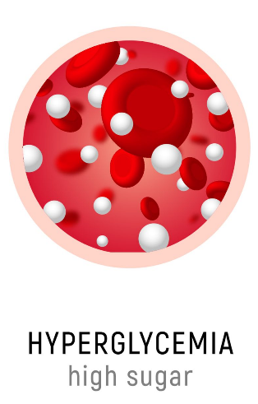 | Needs Insulin  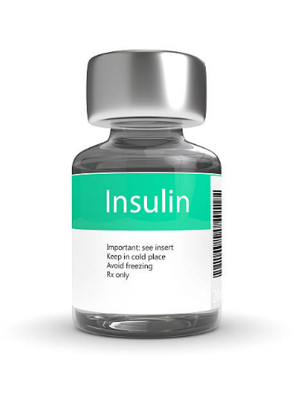
Cold and Clammy-Needs Some Candy   | 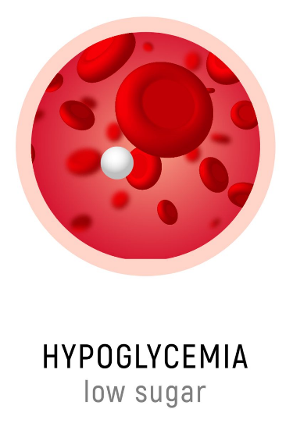 | Needs Some Sugar  