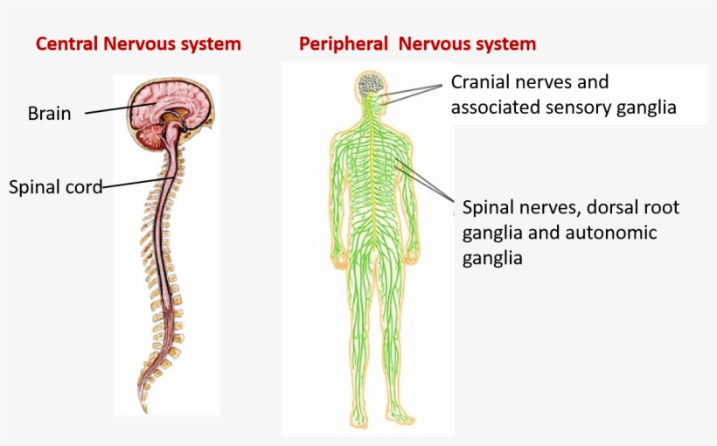



Brain & Spinal Cord

Somatic

Intentional Movement

Nerves

Autonomic

Unintentional

Parasympathetic

Sympathetic

AGNOSIA: the inability to recognize objects

AURA: any number of sensory disturbances that occur before the onset of a migraine headache (warning system)

APHASIA (EXPRESSIVE): patient can understand spoken words but cannot speak

AUTONOMIC EVENT: initially is an extremely stressful or frightening event that will cause a sympathetic reaction

CUSHING RESPONSE: Hypertension, Bradycardia and Widened Pulse Pressure (in response to ⭡ICP)

DYSARTHRIA: poorly articulated speech due to weakness of speech muscles

DECORTICATE POSTURING: flexion of the arms, wrists, fingers, with adduction (everything moves toward the CORE

DECEREBRATE POSTURING: extension of the extremities with some abduction

FUND OF KNOWLEDGE: information processing, intelligence and Formal and Informal Education, (Asking who the president is or to count backward by 3s)

INTRACRANIAL PRESSURE: if increased can cause coma and death, early sign is decreased level of consciousness, late signs are the ***CUSHING RESPONSE.***

LIPOFUSCIN: one of the aging or "wear-and-tear" pigments, found in the liver, kidney, heart muscle, retina, adrenals, nerve cells, and ganglion cells

MYELIN: waxy substance that covers neuron fibers and increases rate of impulse transmission

MYELOGRAM: diagnostic procedure used to identify lesions by observing dye flow through the subarachnoid space (check for allergies BEFORE the procedure and sensation in lower extremities AFTER the procedure)

NEUROTRANSMITTERS: responsible for the transmission of impulses between synapses

NYSTAGMUS: involuntary rhythmic movement of the eyes

OLFACTORY NERVE: responsible for sense of smell

POSTICTAL PERIOD: stage after a seizure where the patient appears groggy and lethargic

PROPRIOCEPTION: the sensation pertaining to spatial position and muscular activity stimuli originating from within the body.

RETICULAR ACTIVATING SYSTEM (RAS) responsible for concentration, wakefulness, attention and introspection.

SURGICAL NAVIGATION SYSTEMS (Robotic Assisted Surgery): is a computerized device that helps guide the surgeon.

Glasgow Coma Scale

FAST FACTS

Always approach a stroke victim from their UNAFFECTED side.

Bending over, lifting, suctioning, coughing, or stimulating the cough response will ALL increase ICP.

Normal effects of aging on the nervous system include:

* Loss of neurons
* Reduction in cerebral blood flow
* Lipofuscin
* Decrease in oxygen use

Meningitis can be bacterial or viral. Symptoms include fever, headache, stiff neck, and photosensitivity. Patient must be on respiratory isolation. A spinal tap will be done to culture and analyze the fluid. Presence of reduced chloride and glucose levels in the CSF would indicate bacterial.

It sometimes takes days after head trauma to show symptoms.

After head trauma some symptoms will resolve on their own…they may be temporary.

Always keep the person with suspected head or spinal injury in straight alignment…keep the neck in a neutral position

If a spinal cord injury complains of stuffiness in the nose and headache with goose bumps sit them straight up and check their BP

Seizure patients will be allowed to drive once their seizures have been under control for a period of time.

|  |  |  |  |
| --- | --- | --- | --- |
| DISEASE | PATHO/SYMPTOMS | TREATMENT | NOTES |
| Trigeminal neuralgia | It is caused by damage or pressure on the **trigeminal** nerve, which provides feeling to the face. causes episodes of stinging or shock-like pain in the face. | Anticonvulsants (carbamazepine)  Anti-spasmodic (baclofen)  Botox  Some surgical procedures to damage the trigeminal nerve or its blood supply. | Can last several years or be lifelong.  Activation of trigger points cause symptoms (touching the face, shaving, eating, smiling) |
| Multiple Sclerosis | Autoimmune disease that causes progressive demyelination with symptoms including diplopia, vertigo, loss of joint sensation, and nystagmus. These episodes usually have flare ups and remissions. | Corticosteroids (prednisone)  Interferon Beta Blockers (copaxone) |  |
| Parkinsons | a progressive disorder that affects the nervous system and the parts of the body controlled by the nerves. Symptoms start slowly. The first symptom may be a barely noticeable tremor in just one hand. Tremors are common, but the disorder may also cause stiffness or slowing of movement (rigidity and bradykinesia, shuffling with arms flexed. | Sinemet (carbidopa levodopa)  May need to go on “drug holidays where they dont take the medication for a period of time so they can restarts the drugs at a lower dose with good effect. | Encourage patient to walk with hands clasped behind back to help balance |
| Gullain-Barre | Autoimmune disease that attacks the myelin and the axons. | Immunoglobulin  Plasma Exchange (plasmapheresis) | Can rapidly progress to respiratory failure  Often have an allergy to eggs |
| Bells Palsy | Initial symptoms are inability to wrinkle forehead and pucker lips on the affected side…with eventual facial paralysis. No known cause. | Corticosteroids (Prednisone)  Antivirals (Zanamivir) |  |
| Alzheimers | Most often diagnosed when there is memory loss that disrupts daily life and functioning. | Memantine  Donepazil  AChE inhibitors (cholinesterase inhibitors) | Sundowning happens in the second stage. |
| Dementia | NOT always Alzheimer’s | Depends on the type | There is a condition caused pseudodementia that can be caused by hypotension and depression…this IS REVERSABLE! |
| Myasthenia Gravis | A neuromuscular disorder that leads to weakness of skeletal muscles. Symptoms are similar to stroke…facial droop, slurred speech, etc. | Prostigmin and Mestinon are used to help promote nerve impulse transmission |  |
| Migraines | Headaches that cause severe throbbing, nausea, vomiting, and photosensitivity. They can last hours or days and there is know real known cause | OTC pain relievers  Sumatriptan (pills, shots or nasal spray)  PREVENTATIVE:  Tricyclic antidepressants (amitriptyline, duloxetine)  Antiseizure Drugs (Topamax)  Botox | Avoid yogurt, caffeine, marinated foods. |

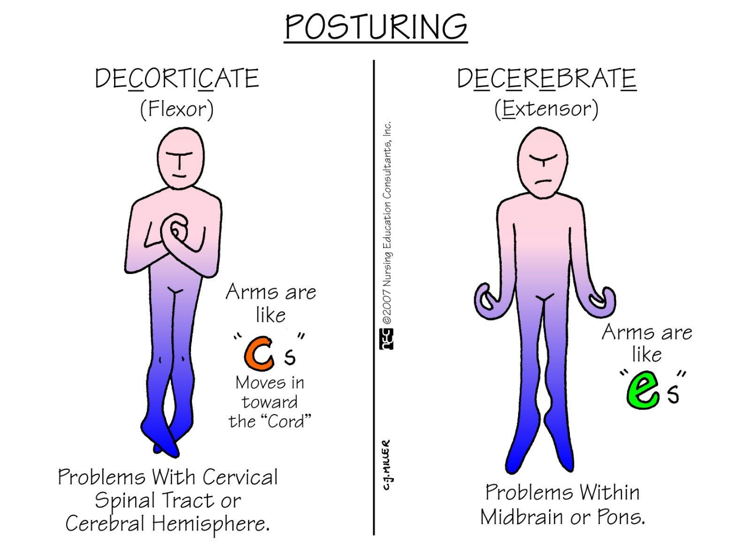

|  |  |
| --- | --- |
| Hemorrhagic Stroke (CVA) | Ischemic Stroke (CVA) 87% |
| These are strokes caused by bleeding. About 13% of all strokes are hemorrhagic. | These are strokes caused by blockage of an artery (or, in rare instances, a vein). About 87% of all strokes are ischemic. |
| * **Intracerebral hemorrhage.**Bleeding is from the blood vessels within the brain. * **Subarachnoid hemorrhage.** Bleeding is in the subarachnoid space (the space between the brain and the membranes that cover the brain). | * **Thrombotic strokes.**These are caused by a blood clot that develops in the blood vessels inside the brain. * **Embolic strokes.** These are caused by a blood clot or plaque debris that develops elsewhere in the body and then travels to one of the blood vessels in the brain through the bloodstream. |
| TREATMENT: if the patient is on blood thinners give the ANTIDOTE  Surgery to remove the blood and relieve pressure  Surgical clipping to clip off the bleeding vessel  Stereotactic Radiosurgery uses beams of highly focused radiation to repair blood vessel malformation (least invasive) | TREATMENT: emergency IV injection of “clot buster” (TPA or TNKase)  This MUST be given within 3 hours of the onset of symptoms |
| PROGNOSIS depends on the severity | PROGNOSIS depends on the severity |

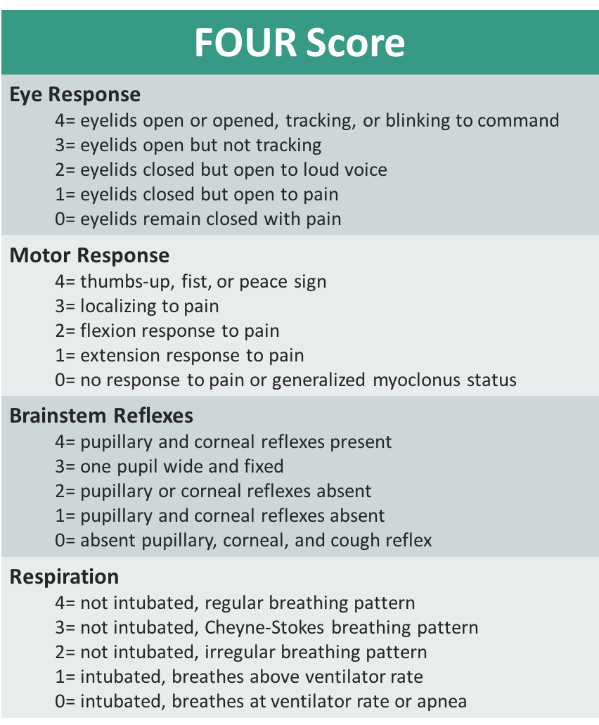

**NOTE that when using the FOUR Score tool the results are reported as individual scores in each category (unlike the Glasgow where they are added up for a total score)**