**Homeostasis** is the tendency to resist change in order to maintain a stable, relatively constant internal environment.

Homeostasis typically involves **negative feedback loops** that counteract changes of various properties from their target values, known as **set points**.

**Pituitary gland** is considered the “Master Gland”

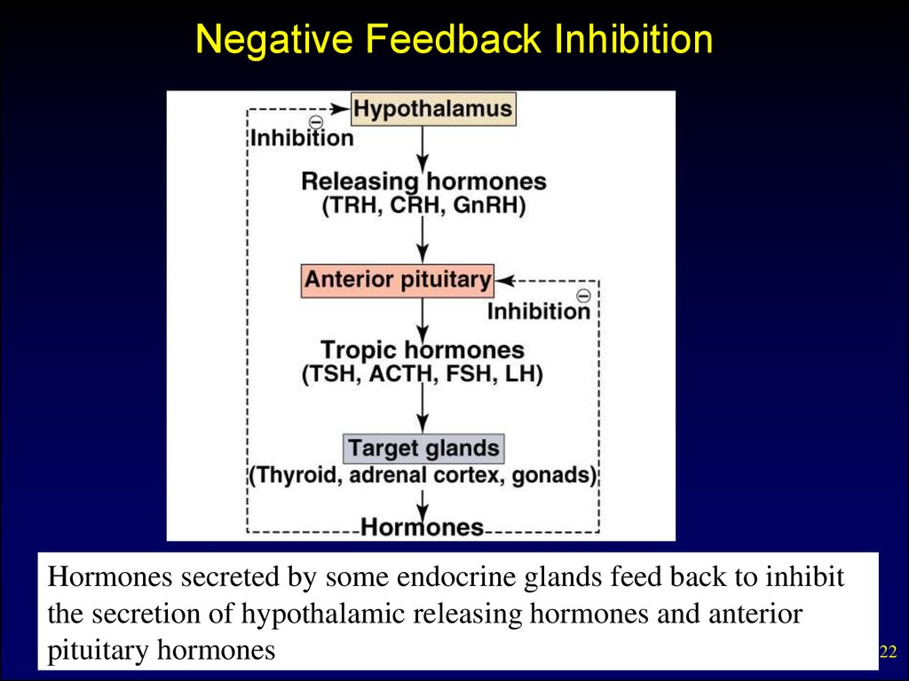

[Glucose](https://www.verywellhealth.com/glucose-5188205) (sugar) is the body's main source of energy.

The body's positive and negative feedback loops keep glucose levels within this narrow range. Whenever blood sugar rises or falls, the body will respond by releasing hormones that either "turn on" or "turn off" the release of glucose from the [liver](https://www.verywellhealth.com/why-is-the-liver-so-important-1760011) to keep levels stable.

In the simplest terms, two different hormones produced by the same organ are involved in maintaining tight control of blood sugar:

* [Glucagon](https://www.verywellhealth.com/glucagon-glucagon-hydrochloride-injection-7092752) is a hormone produced from so-called alpha cells in the [pancreas](https://www.verywellhealth.com/pancreas-anatomy-4800990). When blood sugar levels are low, glucagon is released and stimulates release of glycogen from the liver as part of the positive feedback loop.
* [Insulin](https://www.verywellhealth.com/how-insulin-works-in-the-body-1087716) is a hormone produced by beta cells of the pancreas. When blood sugar levels are sufficient, insulin is released as part of the negative feedback loop.

**Type 1 diabetes**

The body does not make insulin. The immune system attacks and destroys the cells in the pancreas that make insulin. Type 1 diabetes is usually diagnosed in children and young adults, although it can appear at any age. People with type 1 diabetes need to take insulin every day to stay alive.

**Type 2 diabetes**

The body does not make or use insulin well. Type 2 diabetes can occur at any age, even during childhood. However, this type of diabetes occurs most often in middle-aged and older people. Type 2 is the most common type of diabetes.

ORAL drugs like glyburide only work in Type 2 as they stimulate insulin secretion and increase sensitivity at the receptor sites.

**Diagnostic testing and Diabetes**

**Glycosylated hemoglobin (HbA1c)** provides an average measurement of glucose levels for the previous 12 weeks.

**Fasting Blood Sugar** gives immediate feedback to what the blood sugar levels are at that moment.

**Oral Glucose Tolerance Test** (OGTT) measures how well your body PROCESSES glucose once it is ingested.

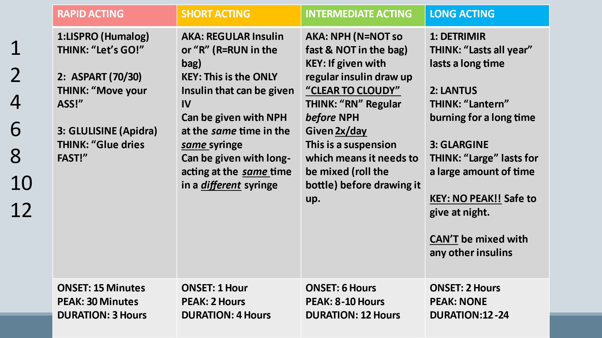

Always give insulin at room temperature to prevent lipohypertrophy.

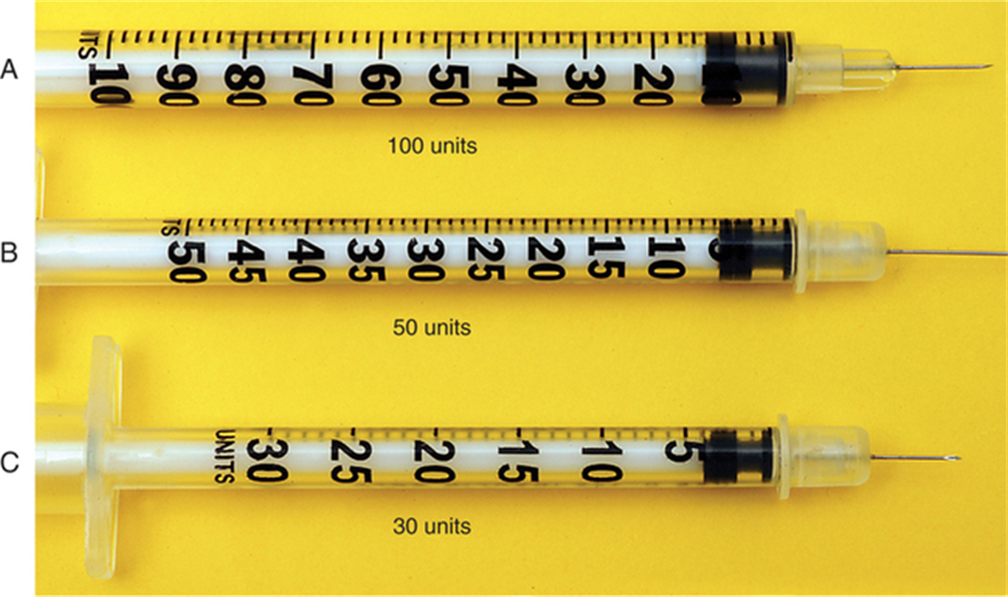

1 unit increments

1 unit increments

2 unit increments

**How to mix short-acting (clear) insulin and intermediate-acting (cloudy) insulin**

**Step 1: Roll and clean**

Wash and dry your hands. Roll the cloudy (intermediate-acting) bottle of insulin between your palms 10 times gently. Do not shake vigorously. Clean the top of vial with an alcohol swab.

**Step 2: Add air to cloudy (intermediate-acting) insulin**

Draw the required amount of air (equal to the dosage of cloudy insulin) into the insulin syringe. Inject air into the cloudy insulin vial. Do not draw out any insulin, and remove the syringe and needle.

**Step 3: Add air to clear (short-acting) insulin**

Using the same syringe and needle, draw the required amount of air (equal to the dosage for clear insulin) into the insulin syringe. Inject air into the clear insulin vial.

**Step 4: Withdraw clear (short-acting) insulin first, then cloudy (intermediate-acting) insulin**

With the insulin syringe and needle attached, turn the clear insulin bottle upside down, with the needle bevel within the insulin, withdraw the required amount of clear insulin into the syringe.

Then do the same with the cloudy insulin. Always withdraw clear insulin first before withdrawing cloudy insulin. Ensure the total dose of clear and cloudy insulin is correct. If overdrawn, discard and repeat.

|  |  |
| --- | --- |
| Hypoglycemia (or insulin reaction) | Hyperglycemia |
| “Cool and Clammy needs some Candy!” | “Hot and Dry Sugar High!” |
| Drowsiness  Lethargy  Hunger  Trembling/Shaking  Cool/Moist Skin  Sweating  Irritability  Lack of Coordination  Rapid SHALLOW respirations | Headache  Weakness  Dry Mouth  Flushed Skin  Increased Thirst  Frequent Urination  Blurred Vision  Deep Heavy Breathing |
| Give 6oz of Orange Juice and recheck Blood sugar in 15 minutes  Prevent by giving snacks between meals especially with LONG acting insulin. | Check Blood Glucose and Treat Accordingly |

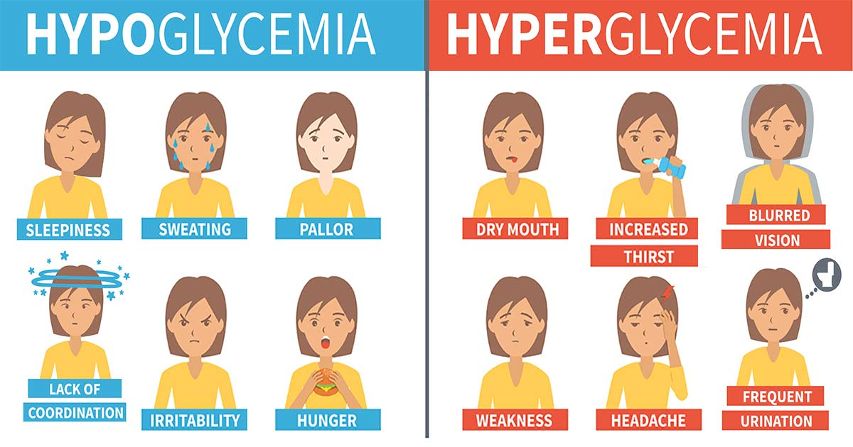

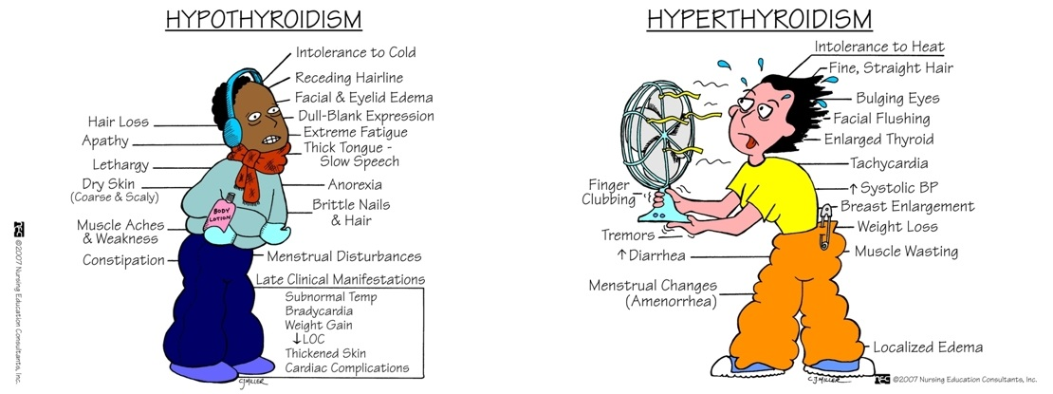

Thyroid Disease (Euthyroid is normal Thyroid)

Normal serum thyroxine levels are 5-12mcg/dl

|  |  |
| --- | --- |
| Hypothyroidism | Hyperthyroidism |
| Slows metabolism  Plan calorie restricted meals with intake of iodine (ie: eggs, iodized salt, seaweed, non-fat milk) | Speeds up metabolism  Nutritious diet should include lean meats, leafy green vegetables and supplemental vitamin D. |
| Treatment:  Synthetic thyroid hormone (Synthroid/levothyroxine)  Will need routine labs for LIFE to monitor thyroid function and adjust medication. | Treatment:  Radioactive iodine is given to destroy some or all of the thyroid tissue.  Cannot be used in pregnant women (nor can iodine 131 test)  Pregnant women cannot be near the patient for 3 days after a dose is given.  Methimazole can be given to block production of thyroid hormone. |
| Thyroidectomy:   * Always have a tracheostomy tray at the bedside * Major complications include hemorrhage, tetany, thyroid storm. * Monitor for thyroid storm (fever, dyspnea, tachycardia, hypertension, distended neck veins…late stage would be congestive heart failure and death. * Monitor for tetany (involuntary or jerking movements) * Turn the patient frequently (while maintaining anatomic position) to check for bleeding that might be pooling behind the neck. * Keep in semi fowler position * Do a voice check every 2 hours | |

|  |  |
| --- | --- |
| Parathyroid hormone controls calcium and phosphorous levels in the blood. | |
| |  |  | | --- | --- | | Hyperparathyroidism | Hypoparathyroidism | | |
| Primary Cause:  Hyperplasia: two or more enlarged parathyroid glands  Secondary causes:  Kidney disease  Vitamin D deficiency  Severe Calcium deficiency | Causes:  Accidental removal or damage during thyroid surgery or neck surgery  Autoimmune disease attacking the parathyroid glands  Genetics  Radiation |
| Symptoms:  Hypercalcemia  Weak Bones/bone pain  Kidney Stones  General malaise  Excessive urination  Abdominal pain | Symptoms:  Hypocalcemia  Laryngeal spasms  + Chvostek and Trousseau signs  Tingling in the fingers, toes, and lips  Muscle aches and cramping  Twitching or spasms of muscles  Depression and/or Anxiety |
| Primary treatment is parathyroidectomy.  Secondary treat the cause | Treatment is calcium and vitamin D supplementation and a high calcium diet to include, canned fish with bones, cucumbers, tofu  Calcium gluconate IV (monitor for hypotension!) |

ADH, also known as vasopressin, is a [hormone](https://my.clevelandclinic.org/health/articles/22464-hormones) that your [hypothalamus](https://my.clevelandclinic.org/health/articles/22566-hypothalamus) makes and your [posterior pituitary](https://my.clevelandclinic.org/health/body/23150-posterior-pituitary) stores and releases.

ADH plays a role in the following processes:

* The balance of water and salt (sodium) in your blood.
* [Blood pressure](https://my.clevelandclinic.org/health/diseases/17649-blood-pressure) regulation.
* [Kidney](https://my.clevelandclinic.org/health/body/21824-kidney) functioning.

More specifically, ADH helps the kidneys control the amount of water the body loses through urine. SIADH causes the body to retain too much water. DI causes the body to lose too much water.

|  |  |
| --- | --- |
| Diabetes Insipidus | SIADH (Syndrome inappropriate ADH) |
| ⭣ADH  ⭣Water in body  ⭡Urine Output  Polyuria  ⭡Na+ from concentrated blood  ⭡H&H and serum osmolality from Dehydration  ⭣Urine specific gravity | ⭡ADH  H2O Intoxication  ⭣Urine Output  Oliguria  ⭣Na+ (diluted blood)  ⭣Serum Osmolality  Weight Gain |
| CAUSES:  Tumor or infection of the pituitary gland  Head injury  Genetic disorder  Chronic Kidney disease  Medications (antivirals) | CAUSES:  Opiate use  Certain cancers  CNS issues  Medications  Hypopituitarism  Hypothyroidism |
| RISK:  Hypovolemic shock (protect from injury) | RISK:  Seizures |
| Treatment:  DDAVP (ADH)  Treat the cause | Treatment:  Fluid Restriction  Treat the cause |

The adrenal cortex secretes glucocorticoids with the most important being cortisol which is involved in glucose metabolism and providing extra reserve energy during stress.

|  |  |
| --- | --- |
| Addison’s | Cushing’s |
| Too little steroid hormone | Too much steroid hormone |
| Extreme fatigue  Weight loss  Anorexia  Salt craving  Hypoglycemia | Weight gain in the abdomen and face  “Buffalo Hump”  Striae (Stretch Marks)  Thin frail skin  Slow wound healing |
| Hormone replacement  Glucocorticoids  Aldosterone replacement | Place on low sodium diet  ***Taper off*** glucocorticoid drugs if possible  Surgery if pituitary tumor |

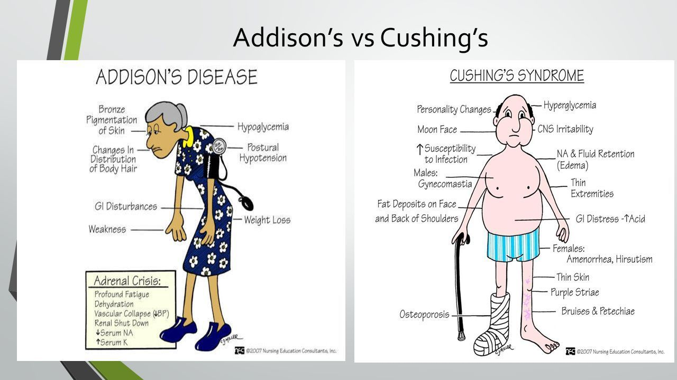

The adrenal medulla releases the hormones needed for “fight or flight”

FAST FACTS

Acromegaly symptoms are enlarged hands and feet, amenorrhea, increased hair growth and is due ***hyper***pituitarism

Acromegaly patients are at risk for trauma and should be given a soft easy to chew diet (enlarged tongue)

Growth deficiency like dwarfism is caused by ***hypo***pituitarism

Sexual development will be delayed in dwarfism